Match the photo of the city to the correct country.

1. 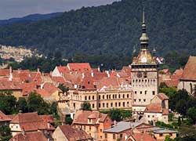 The clock tower in Sighisoara
2. Poland
3. Turkey
4. Spain
5. Romania

Answer: d

1. 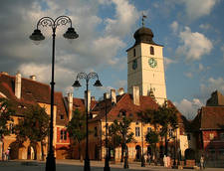 The council tower of Sibiu
2. Spain
3. Romania
4. Bulgaria
5. Italy

Answer: b

1. 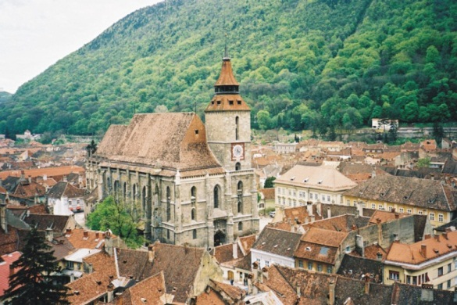 The Brasov Black Church
2. Romania
3. Italy
4. Spain
5. Bulgaria

Answer: a

1. 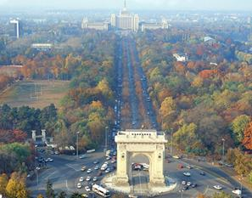 Arcul de triumph/Triumphal Arch, Bucharest
2. Spain
3. Italy
4. Poland
5. Romania

Answer: d

1. 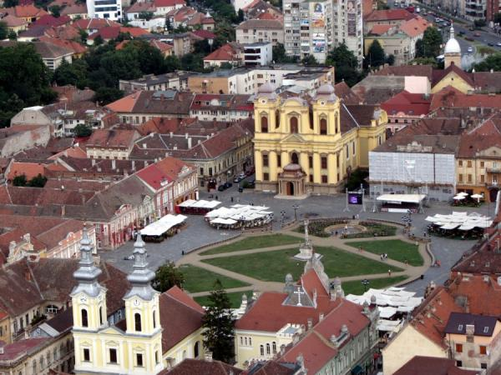 Piata Unirii/Union Square, Timisoara
2. Poland
3. Romania
4. Italy
5. Turkey

Answer: b